Statik og Styrkelære – Course Project 2

Mikkel Klitgaard Nissen – 202407678
Mathias Donnerup Rasmussen – 202405101
Noah Rahbek Bigum Hansen – 202405538
December 3rd, 2025

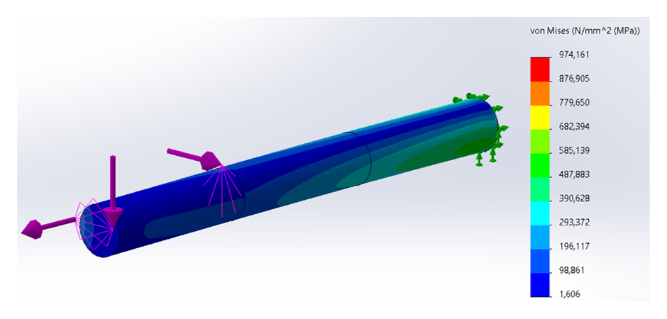

Introduction
This project investigates the stress state in a beam subjected to combined loading, using both analytical methods and Finite Element Method (FEM)-simulation. In many real-world scenarios, components experience both axial forces, bending moments, and shear forces simultaneously – Hence, it is important to be able to predict the resulting stresses and assess the validity of said prediction. Here, Euler–Bernoulli beam theory is used to describe the behaviour of a beam experiencing combined loading, and the resulting normal and shear stresses are evaluated at three selected points on the cross-section.

In the first part of the report, the stress state at points A, B, and C are determined analytically by combining the axial, bending and shear contributions. The stress state at each point is represented on a local differential volume element for each point, where the stress components are expressed in a local coordinate system. Lastly, the Von Mises stress is computed for each point, and this is compared to the yield strength of the Plate Carbon Steel beam to determine if the beam will yield under the given loading.

In the second part, the same geometry and loading is studied numerically using a three-dimensional FEM model in SOLIDWORKS simulation. A static study, with a bonded, partitioned cylinder and external loads is set up, and the stress components at the point of interest are probed. A simple mesh convergence study is carried out to evaluate the reliability of the FEM results, and the analysis is repeated until convergence is reached.

In the third part, the numerical results are compared to the analytical predictions, the percentage deviations and corresponding root mean square deviations are calculated, and possible sources of discrepancy are discussed, including modelling assumptions and mesh refinement effects.

Analytical Stresses in the Beam
Determine the state of stress for points A, B and C.
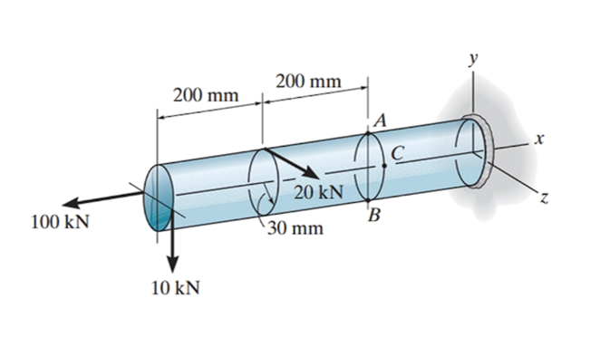
Figure 1: Statics problems 13-47 to 13-49
- Calculation of internal forces and moments
First, the internal forces and moments are obtained from the equilibrium equations. By convention, a moment is considered positive when its vector aligns with the defined positive axis and forces are considered positive if it aligns with the given positive axis. We have,
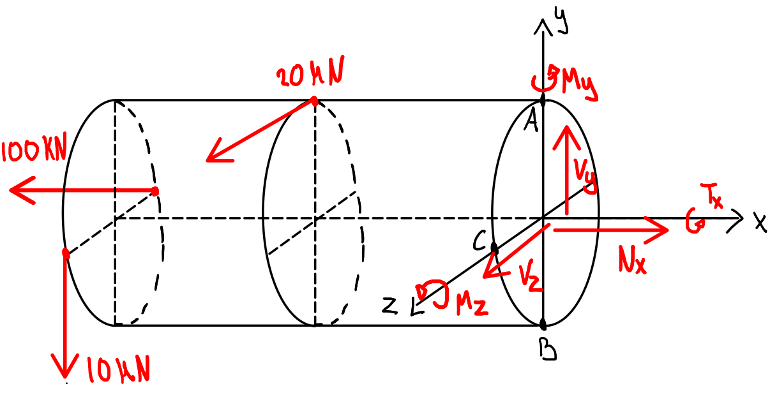
Figure 2: FBD with section cut at points A, B and C
From the FBD we get,
$$\sum{F_{x}=-100kN+N_{x}=0} ⟹N_{x}=100 kN$$
$$\sum{F_{y}=-10kN+V_{y}=0 ⇒ V_{y}=10kN}$$
$$\sum{F_{z}=20kN+V_{z}=0 ⇒ V_{z}=-20kN}$$
$$\sum{T_{x}=20kN·0.03m+10kN·0.03m+T_{x}=0 ⇒T_{x}=-0.9kN·m }$$
$$\sum{M_{y}=100kN·0.03m+20kN·0.2m+M_{y}=0 ⇒M_{y}=-7kN·m }$$
$$\sum{M_{z}=10kN·0.4m+M_{z}=0 ⇒M_{z}=-4kN·m }$$

- Calculation of initial cross-sectional properties for the rod
We make the following sketch, of the cross section at the three points A, B and C
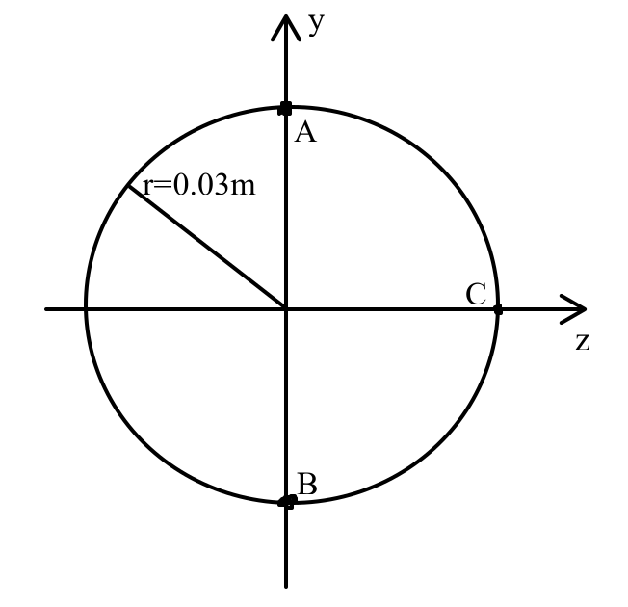
Figure 3: Cross-section normal to x-axis at points A, B and C
For the area we have,
$$A=πr^{2}=0.028 m^{2}$$
And from appendix B in the book, the area moment of inertia for a circle is given as,
$$I_{y}=I_{z}=\frac{1}{4}πr^{4}=6.3617·{10}^{-7}m^{4}$$

- Calculation of the stresses at point A, B and C
Normal stress:
Firstly, the normal stress due to the normal force is computed,
$$σ_{x,A1}=σ_{x,B1}=σ_{x,C1}=\frac{N_{x}}{A}=35.37 MPa$$
This normal stress is assumed uniform over the cross section.
Next, the normal stress due to the bending moments is computed,
$$σ_{x,A2}=-\frac{M_{z}y}{I_{z}}+\frac{M_{y}z}{I_{y}}=-\frac{M_{z}r}{I_{z}}+\frac{M_{y}·0}{I_{y}}=-\frac{M_{z}r}{I_{z}}=188.63 MPa$$
$$σ_{x,B2}=-\frac{M_{z}y}{I_{z}}+\frac{M_{y}z}{I_{y}}=-\frac{M_{z}\left(-r\right)}{I_{z}}+\frac{M_{y}·0}{I_{y}}=\frac{M_{z}r}{I_{z}}=-188.63 MPa$$
$$σ_{x,C2}=-\frac{M_{z}y}{I_{z}}+\frac{M_{y}z}{I_{y}}=-\frac{M_{z}·0}{I_{z}}+\frac{M_{y}r}{I_{y}}=\frac{M_{y}r}{I_{y}}=-330.1 MPa$$
Using the principle of superposition we thus have the total normal stress at each point,
$$σ_{x,A}=σ_{x,A1}+σ_{x,A2}=224.0 MPa$$
$$σ_{x,B}=σ_{x,B1}+σ_{x,B2}=-153.3 MPa$$
$$σ_{x,C}=σ_{x,C1}+σ_{x,C2}=-294.7 MPa$$

Shear stresses:
For shear stress due to shear force, we have,
$$τ=\frac{VQ}{It}$$
Firstly, the shear stress for all points due to the shear force $V_{y}$ is computed. For clarity a sketch is made,
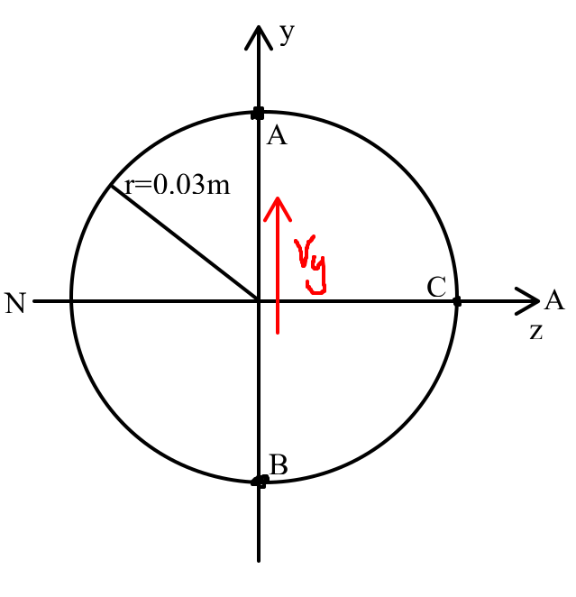
Figure 4: Visualization of shear contribution in y-direction
For point A, we have,
$Q_{xy,A1}={\overline{y}}^{'}A^{'}=0$ and $t_{xy,A1}=0$
Thus,
$$τ_{xy,A1}=0$$
For point B, we have,
$Q_{xy,B1}={\overline{y}}^{'}A^{'}=0$ and $t_{xy,B1}=0$
Thus,
$$τ_{xy,B1}=0$$
For point C, we have,
$Q_{xy,C1}={\overline{y}}^{'}A^{'}=\frac{4r}{3π}\frac{πr^{2}}{2}=\frac{2r^{3}}{3}=1.8·{10}^{-5} m^{3}$ and $t_{xy,C1}=2r=0.06m$ and $I=I_{y}=I_{z}$
$$τ_{xy,C1}=\frac{V_{y}Q_{xy,C1}}{It_{xy,C1}}=4.72 MPa$$
Next, we consider the shear stress for all points due to the shear force $V_{z}$. For clarity a new sketch of the situation is made,
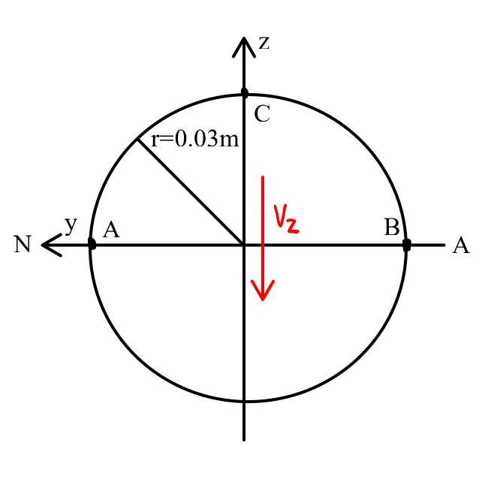
Figure 5: Visualization of shear in z-direction
For point A, we have,
$Q_{xz,A1}={\overline{y}}^{'}A^{'}=\frac{4r}{3π}\frac{πr^{2}}{2}=\frac{2r^{3}}{3}=1.8·{10}^{-5} m^{3}$ and $t_{xz,A1}=2r=0.06m$ and $I=I_{y}=I_{z}$
Thus,
$$τ_{xz,A1}=\frac{V_{z}Q_{xz,A1}}{It}=-9.43 MPa$$
For point B, assuming constant shear stress across the width t we have,
$$τ_{xz,B1}=τ_{xz,A1}=-9.43 MPa$$
For point C, we have,
$Q_{xz,C1}={\overline{y}}^{'}A^{'}=0$ and $t=0$
Thus,
$$τ_{xz,C1}=0$$
Shear stress due to torsional moment:
In general, we have,
$$τ=\frac{Tρ}{J}$$
In our case $J=\frac{π}{2}r^{4}$ and $ρ=r$ is constant throughout the calculations for all points, thus,
$$τ=\frac{T_{x}r}{\frac{πr^{4}}{2}}=\frac{2T_{x}}{πr^{3}}=-21.2 MPa$$
Shear stress due to torsion always acts tangential to the radial position vector. If we zoom in on the FBD for the section cut, we have,
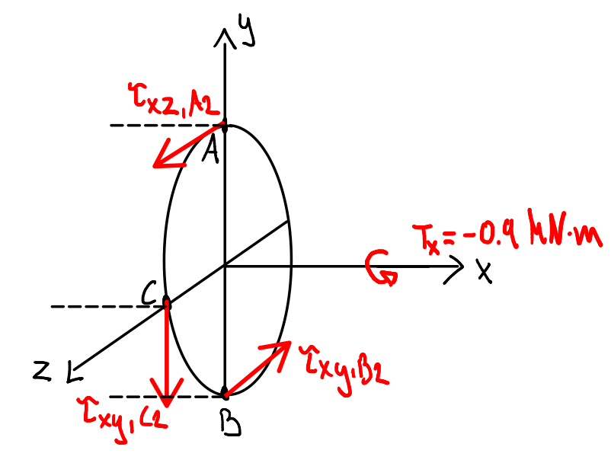
Figure 6: Visualization of torsional shear
Taking the coordinate system into consideration, we get,
$$τ_{xz,A2}=-21.2 MPa$$
$$τ_{xz,B2}=21.2 MPa$$
$$τ_{xy,C2}=21.2 MPa$$
Using the principle of superposition we thus have,
$$τ_{xy,A}=τ_{xy,A1}=0 MPa$$
$$τ_{xz,A}=τ_{xz,A1}+τ_{xz,A2}=-30.7 MPa$$
$$τ_{xy,B}=τ_{xy,B1}=0 MPa$$
$$τ_{xz,B}=τ_{xz,B1}+τ_{xz,B2}=11.8 MPa$$
$$τ_{xy,C}=τ_{xy,C1}+τ_{xy,C2}=25.9 MPa$$
$$τ_{xz,C}=τ_{xz,C1}=0 MPa$$

The stresses at point A, B and C are then
A: $σ_{x,A}=224MPa$, $τ_{xy.A}=0MPa$, $τ_{xz.A}=-30.7MPa$
B: $σ_{x,B}=-153.3MPa$, $τ_{xy.B}=0MPa$, $τ_{xz.A}=11.8MPa$
C: $σ_{x,C}=294.7MPa$, $τ_{xy.C}=25.9MPa$, $τ_{xz.C}=0MPa$

The element at each point is drawn in figure 7 below,
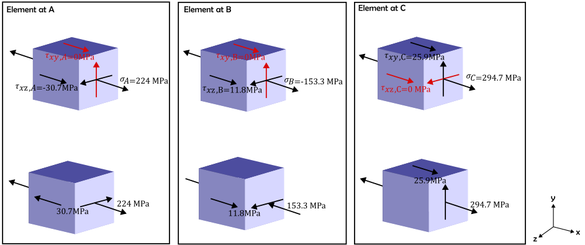
Figure 7: Volume elements at points A, B and C
Note on the result:
For comparison, the yield strength supplied by the solid works library for plain carbon steel Is $220.6 MPa$. If we compute the von misses stresses for the 3 points, we can see If this yield strength Is exceeded,

In general, we have,
$$σ_{vM}=\sqrt{σ_{x}^{2}-σ_{x}σ_{y}+σ_{y}^{2}+3\left(τ_{xy}^{2}+τ_{yz}^{2}+τ_{xz}^{2}\right)}$$
However, in our case, we have that $σ_{y}=τ_{yz}=0$. Thus,
$$σ_{vM}=\sqrt{σ_{x}^{2}+3\left(τ_{xy}^{2}+τ_{xz}^{2}\right)}$$
$$σ_{vM,A}=230.2 MPa$$
$$σ_{vM,B}=154.7 MPa$$
$$σ_{vM,C}=298.1 MPa$$
We see that $σ_{vM,C}>σ_{vM,A}>220.6 MPa$.
General analytical stress formulas used in this analytical solution are valuable for simple, linear elastic, prismatic structures under pure loads, but their accuracy breaks down when material behaviour becomes nonlinear, deformations become large, yielding is exceeded or loading states combine and interact. In this case, we do have a combined loading, and we have demonstrated that the stress state in point A and C exceed the yield strength for plain carbon steel, which will generate some expected error compared to the more realistic FEM analysis.

Simulated Stresses in the Beam
Following the instructions given by the assignment specifications, multiple FEM analyses were made using the SolidWorks simulation tool. On fig. 8, the final stress plot in the true scale deformed configuration is shown with Von Mises Stress.

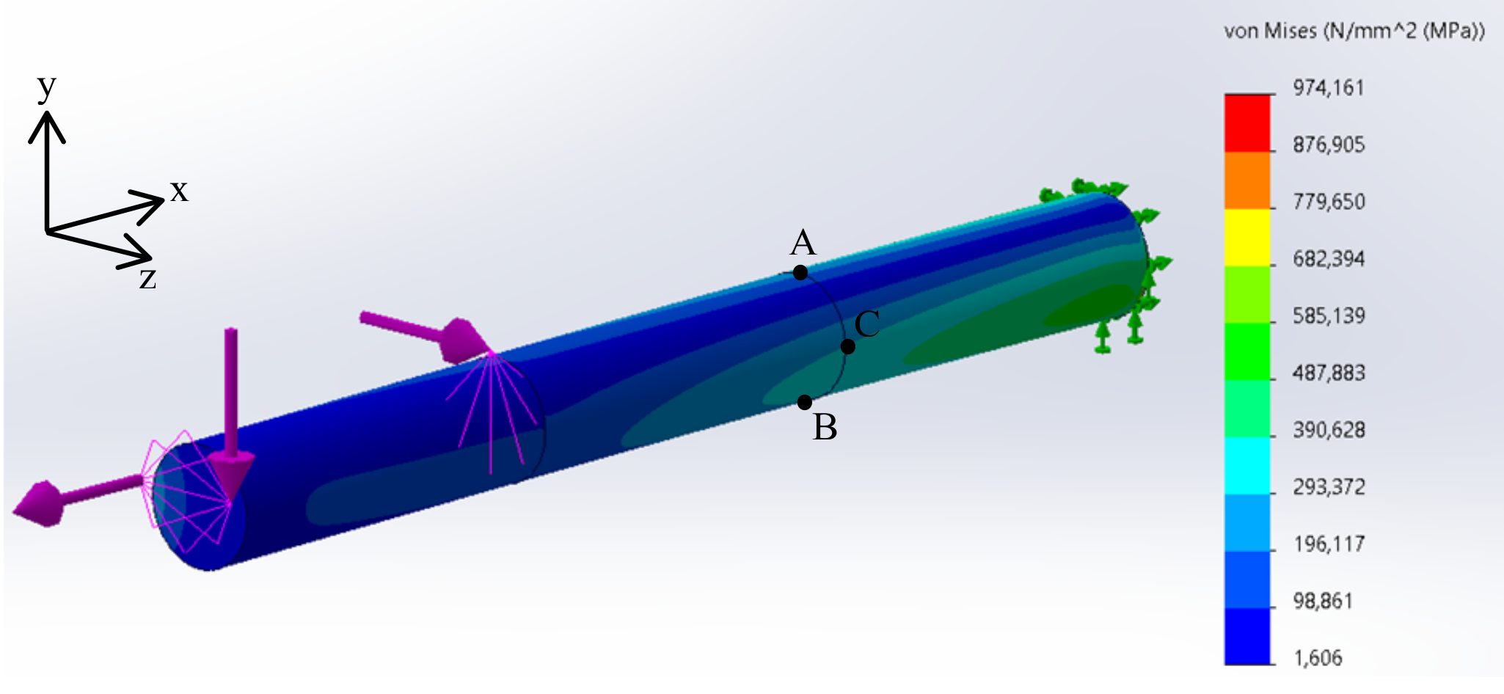
Figure 8: Final stress plot with true scale deformation and Von Misses Stress
The geometry of the problem was made using a sketch In SolidWorks of a circle with diameter of 60 mm and extruding that surface by 600mm. To make prope and load positioning simpler, the extruded figure was sectioned into three 200mm long parts. Using the probing tool at points A, B, and C, the normal stress in the x-direction was obtained as well as the shear stresses in the yz-plane, resolved in both the y- and z-directions. The applied forces were modeled with the specified locations, directions, and magnitudes given in the problem using the 'remote load/mass' tool in SolidWorks. Location and directions were specified using a reference coordinate system placed at the load application point. A fixture was made with the 'fixed geometry' tool to replicate the boundary condition (cantilever beam) for the problem.

The displacement of the beam at the three points was measured using the probe to be 1.58 mm for point A, 1.47mm for point B and 1.58mm for point C. Since these displacements are small relative to the size of the body, the assumption of small displacement in the analytical approach is reasonable. Although small inaccuracies are still present.
Since the beam is subjected to a relatively simple loading case for which the analytical formulas are fully applicable, the analytical solution is appropriate here. FEM is therefore more relevant for cases involving complex geometries or loading conditions where analytical expressions are no longer valid.

To ensure numerical stability and sufficient accuracy, a mesh-refinement study was performed in which the element size was gradually reduced until the change in results between successive iterations was below 5%. The corresponding convergence plots and relative deviations are shown in Figures 9–14 along with the stress values for point A, B and C. The final mesh used in the analysis has an element size of approximately 1.6 mm. It should be noted that some stresses converge toward zero, and therefore their percentage deviation does not fall below 5%. Since the absolute values approach zero, these results are still considered converged and physically meaningful.

Figure 9: Normal stress in x direction Figure 10: Shear stress in yz-plane along y direction

Figure 1111: Shear stress in yz-plane along y direction Figure 12: Normal stress change from last value

Figure 13: Shear stress in yz-plane along z direction Figure 14: Shear stress in yz-plane along y direction
change from last value change from last value
It is seen that the normal and shear stresses all approach a single value, with decreasing change from the last value. However, alle stresses approaching a value of 0 seem to converge badly compared to the rest of the values. This however is because calculations of change from previous values are based on that previous value, meaning that if the initial value was close to zero, then only a very small deviation causes a large relative difference. It is also worth noting that the absolute deviation from the previous value at the last iteration for the zero stress values are below 0,2 MPa which is could be attributed to the variability of the mesh when created in Solidworks. Using a very small mesh size would then be required to allow for a change from precious value within 5%. Due to limitations of the device running the FEM analyses, it was determined that a change of close to 5% for all values not converging to zero is satisfactory. At the last iteration this was achieved.

To sum up the results achieved from the FEM simulation in the final Iteration with an element size of approximately 1.6 mm, we get for the stresses at point A, B and C,
A: $σ_{x,A}=228.2MPa$, $τ_{xy.A}=-0.4MPa$, $τ_{xz.A}=-29.8MPa$
B: $σ_{x,B}=-157.4MPa$, $τ_{xy.B}=0.2MPa$, $τ_{xz.A}=12.7MPa$
C: $σ_{x,C}=-294.8MPa$, $τ_{xy.C}=25.7MPa$, $τ_{xz.C}=0.0MPa$

Discussion
Now, the stress components at points A, B and C have been found both analytically and by simulation. The percentage deviation between the simulation and analytical approach for each of these stress components at each point has been calculated as shown in appendix B. From this, we see that the individual deviations for the different components are in the range -3%–8%. It should be noted, that for three datapoints, no deviation has been calculated as the analytical result here is 0, leading to the percentage deviation being undefined.

To get a better overview of the general deviation between the two methods the root mean square (RMS) deviation between the 6 defined deviations (i.e. the 3 datapoints where the analytical result was 0 have not been included) has been found using the formula for the RMS:
$$RMS\left(PD\right)=\sqrt{\frac{1}{N} \sum_{i}{PD_{i}^{2}}}.$$
Following this method, the total RMS for the 6 defined deviations has been found to be 3,6%.
Following the same approach for the three calculated von Mises stresses, the percentage deviations are in the range 0%–2,7% with an RMS of 1,9% for just these three datapoints.

The obtained RMS values are a concise measure of the overall agreement between the idealized analytical methods and the FEM results. For the individual stress components at the three points an RMS of just 3,6% is obtained. Given the typical uncertainties associated with the idealized analytical methods and numerical discretization, the found RMS deviation is considered very satisfactory. For the von Mises stresses, which can be thought of as a scalar measure combining all the stress components, the RMS is just 1,9%. This means that not only are the individual stress components well approximated; the general stress state is approximated at an even better accuracy.

Conclusion
The aim of this project was to determine the stress state in a circular cantilever beam under combined loading using classical analytical methods and a three-dimensional FEM-model. Using Euler–Bernoulli theory, the normal and shear stresses at points A, B and C were determined and combined into von Mises stresses, which showed that the yield strength of the plain carbon steel is exceeded slightly at point A and more severely at point C. The corresponding FEM study, including a simple mesh convergence analysis, produced stress components and von Mises stresses that agree closely with the analytical predictions. The percentage deviations were within −3%–8%, corresponding to an RMS deviation of 3.6% (of the 6 non-zero datapoints), while the von Mises stresses differed by only 0%–2.7% with an RMS of 1.9%.

These results indicate that, despite the simplifying assumptions of Euler–Bernoulli beam theory, the analytical approach provides a very good approximation of the actual stress state for this loading case. The largest relative deviations occur for stress components that approach zero, where percentage errors are naturally more sensitive, but the absolute differences remain small and physically reasonable.

Based on the small deviations between the different methods more research is needed to completely understand the intricacies of FEM and in which cases, it might not be applicable – Based on the close correlation between the two methods in this scenario, we can however, conclude that at least for the simple case of this report, the methods agree closely on the final result. The converging nature of the results from the FEM method might also give an indication as to the accuracy and representability of the results compared to a real-world case for this specific problem. Although, one should consider the possibility that the FEM could converge to a wrong value due to some of the after mentioned assumptions made using this method as well as singularity issues and variability stemming from the numerical nature of the method.

Appendix

Appendix A – Convergence analysis in Excel
Mesh size(mm) | $σ_{x}$ A (Mpa) | $σ_{x}$ B (Mpa) | $σ_{x}$ C (Mpa)
100,0 | 172,0 | -88,3 | -350,2
50,0 | 160,1 | -109,6 | -334,1
25,0 | 164,0 | -90,0 | -318,3
12,5 | 186,2 | -185,8 | -300,6
6,3 | 239,1 | -137,0 | -296,3
3,1 | 232,3 | -145,0 | -295,2
1,6 | 228,2 | -157,4 | -294,8
Mesh size(mm) | $Δσ_{x}$ A (%) | $Δσ_{x}$ B (%) | $Δσ_{x}$ C (%)
50,0 | 6,9 | -24,1 | 4,6
25,0 | -2,4 | 17,9 | 4,7
12,5 | -13,5 | -106,5 | 5,6
6,3 | -28,4 | 26,3 | 1,4
3,1 | 2,8 | -5,8 | 0,4
1,6 | 1,8 | -8,6 | 0,1
Mesh size(mm) | ${\left(τ_{yz}\right)}_{z}$ A (Mpa) | ${\left(τ_{yz}\right)}_{z}$ B (Mpa) | ${\left(τ_{yz}\right)}_{z}$ C (Mpa)
100,0 | -41,4 | 11,0 | -16,2
50,0 | -33,4 | 8,4 | -9,4
25,0 | -33,5 | 10,1 | -3,2
12,5 | -29,8 | 12,7 | -0,9
6,3 | -29,6 | 12,4 | -0,3
3,1 | -29,7 | 12,5 | -0,1
1,6 | -29,8 | 12,7 | 0,0
Mesh size(mm) | $Δ{\left(τ_{yz}\right)}_{z}$ A (%) | $Δ{\left(τ_{yz}\right)}_{z}$B (%) | $Δ{\left(τ_{yz}\right)}_{z}$ C (%)
50,0 | 19,3 | 23,8 | 41,8
25,0 | -0,3 | -20,3 | 65,8
12,5 | 11,0 | -25,2 | 71,7
6,3 | 0,6 | 2,0 | 67,9
3,1 | -0,4 | -0,6 | 72,7
1,6 | -0,2 | -1,3 | 89,4
Mesh size(mm) | ${\left(τ_{yz}\right)}_{y}$ A (Mpa) | ${\left(τ_{yz}\right)}_{y}$ B (Mpa) | ${\left(τ_{yz}\right)}_{y}$ C (Mpa)
100,0 | 18,6 | 10,4 | 28,9
50,0 | 12,2 | -0,5 | 27,7
25,0 | 6,3 | -2,5 | 27,4
12,5 | 3,7 | 1,6 | 25,9
6,3 | -1,4 | -0,5 | 25,6
3,1 | -0,6 | -0,3 | 25,6
1,6 | -0,4 | 0,2 | 25,7
Mesh size(mm) | ${Δ\left(τ_{yz}\right)}_{y}$ A (%) | ${Δ\left(τ_{yz}\right)}_{y}$ B (%) | ${Δ\left(τ_{yz}\right)}_{y}$ C (%)
50,0 | 34,4 | 105,2 | 4,3
25,0 | 48,1 | -352,2 | 0,9
12,5 | 41,8 | 164,4 | 5,4
6,3 | 138,1 | 132,8 | 1,3
3,1 | 56,1 | 46,1 | 0,1
1,6 | 38,8 | 156,1 | -0,5

Appendix B – Percentage Deviation Data in Excel
 | σ_x
 | A | B | C
FEM | 228,2 | -157,4 | 294,8
Analytic | 224 | -153,3 | 294,7
PD | 1,9% | 2,7% | 0,0%
 | (τ_(yz))_z
 | A | B | C
FEM | -29,8 | 12,7 | 0
Analytic | -30,7 | 11,8 | 0
PD | -3% | 8% | n/A
 | (τ_(yz))_y
 | A | B | C
FEM | -0,4 | 0,2 | 25,7
Analytic | 0 | 0 | 25,9
PD | n/A | n/A | -1%
 | sum FEM (-vM) | sum Ana (-vM) | RMS err (-vM)
 | 374 | 372,4 | 3,61%

